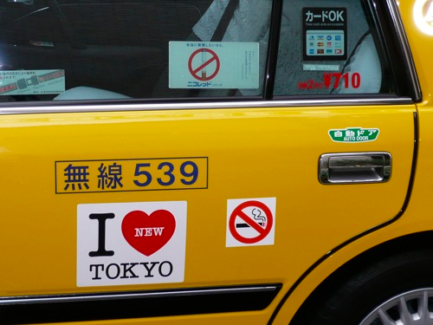
Taxi fares…

Part A

Jake’s Taxis vs. Narissa’s Cabs

Jake’s taxi service offers customers the following deal for taxi rides within the Yokohama area.

- a minimum fare of JPY 500 for the first 2 kilometers followed by,
- JPY 90 for every 300 metres thereafter.

Narissa’s cab service offers customers the standard Tokyo deal, which is,

- a minimum fare of JPY 710 for the first 2 kilometres followed by,
- JPY 80 for every 274 metres thereafter.

Katie, Ken, Ren and Anju are at Landmark Tower and want to call a taxi to get them home as it’s raining.

Katie, Ken, Ren and Anju all live in Tokyo and guess that to get to where they need to go will involve a trip of around 35 - 40 kilometres. Which taxi company should they choose and why?

Part B

The standard Tokyo deal described above isn’t made up…supposedly that’s basically how it works though in reality there’s also a charge of JPY 80 for every two minutes you are not moving!

(see: http://www.tokyotopia.com/tokyo-taxi.html)

The website Taxi Fare Finder (http://www.taxifarefinder.com/main.php?city=Tokyo-Japan ), will give you taxi fares between any two places you want in Tokyo along with the distance and the time for three different speed options.

The example shown below is a journey from Ginza station to Tokyo Dome, which as you can see cost JPY 2 693 for a journey of 7 kilometres in medium traffic.

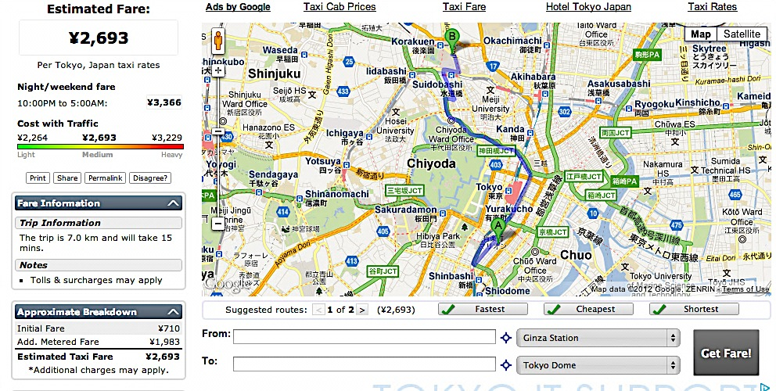

If you were to collect some data for a variety of different journeys…would the cost and distance match Narissa’s Tokyo deal describd above? Or, does the data from this site suggest a different rule?

Hint: if you chose the cost with light traffic each time there’s less chance of the extra costs for having to wait in traffic queues!

